Course: Basics of Computer Science
Course Code: 26COA0101

Submitted BY: Name: Kanwalpreet Singh
Roll no: 2610997039

Submitted TO: Ms. Deepika Sharma
INDEX
No. | COMMANDS | PURPOSE
1 | mkdir | Create directory / folder
2 | cd | Change directory
3 | Cat > | Create / write text file
4 | cp | Copy a file
5 | mv | Move / Rename file
6 | rmdir | Remove file
7 | ls | List directory contents
8 | find | Search for a file

Experiment: 1
1.Create the main BCA_Lab directory.
Input: mkdir BCA_Lab

Output:
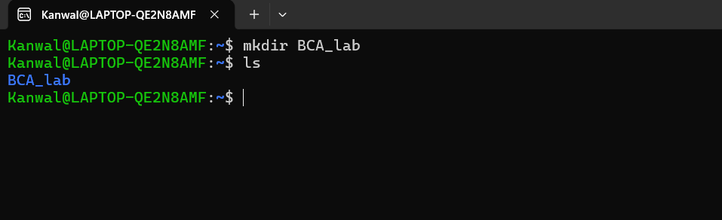

Experiment: 2
2.Enter the BCA_Lab directory.
Input: cd BCA_Lab

Output:
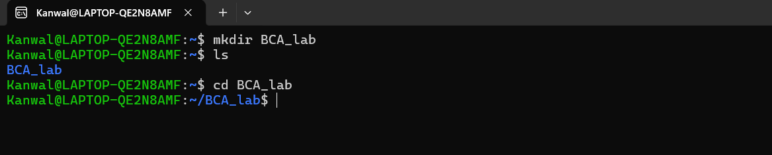

Experiment: 3
3.Create assignments, notes and projects directories.
Input: mkdir assignment notes projects

Output:
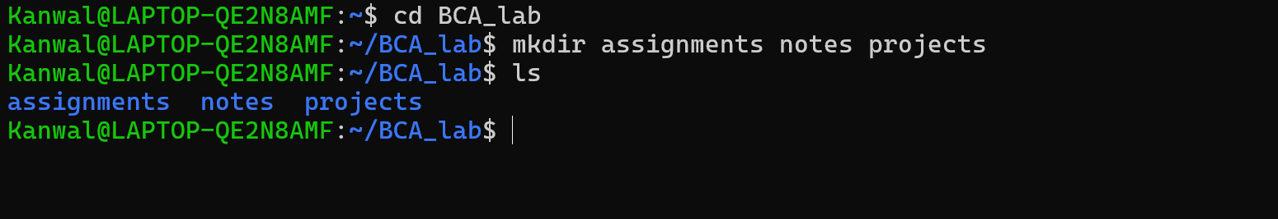

Experiment: 4
4.Enter the assignments directory.
Input: cd assignments

Output:
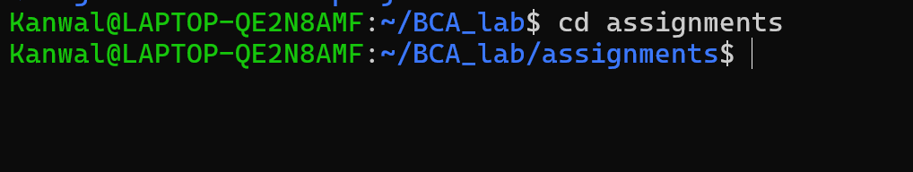

Experiment: 5
5.Create the first assignment file .
Input: cat > assignments1.txt
My name is Kanwalpreet Singh
File input shown above is completed with Ctrl+Z / F6.

Output:
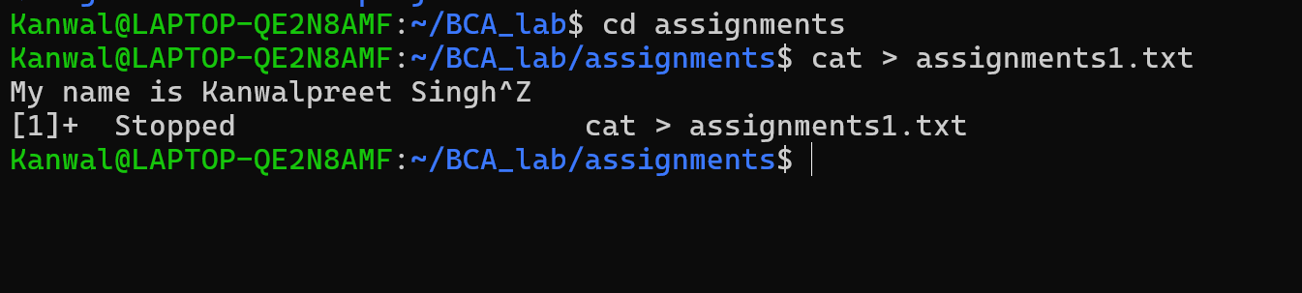

Experiment: 6
6.Create the second assignment file.
Input: cat > assignment2.txt
From Punjab
File input shown above is completed with Ctrl+Z / F6.

Output:
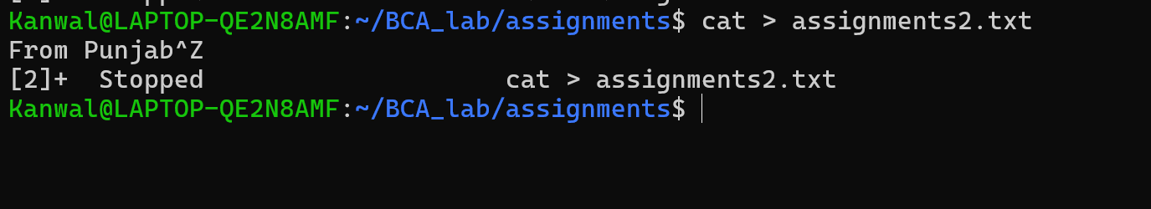

Experiment: 7
7.Copy the first assignment file to projects.
Input: cp assignment1.txt ../projects/

Output:

Experiment: 8
8.Open the projects directory.
Input: cd../projects

Output:
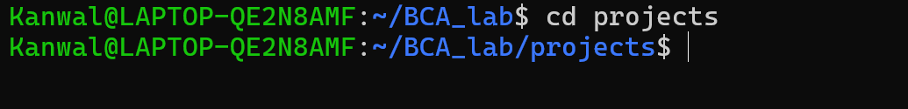

Experiment: 9
9.Display the contents of projects.
Input: ls

Output:
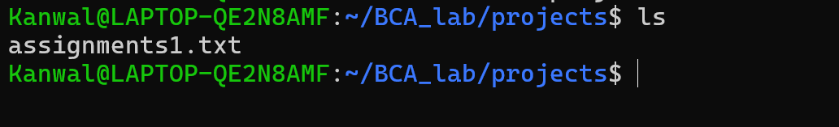

Experiment: 10
10.Return to the BCA_Lab directory.
Input: cd BCA_Lab

Output:
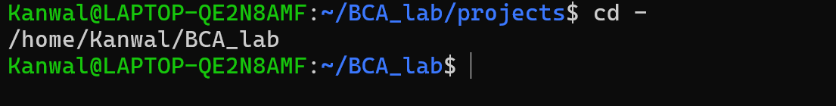

Experiment: 11
11.Enter the assignment directory
Input: cd assignment

Output:
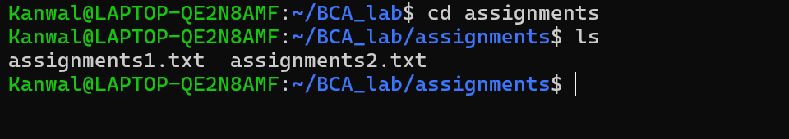

Experiment: 12
12.Move the second assignment file to notes
Input: BCA_Lab / assignments / $ mv assignment2.txt../notes/

Output:

Experiment: 13
13.Return to BCA_Lab
Input: cd BCA_Lab

Output:
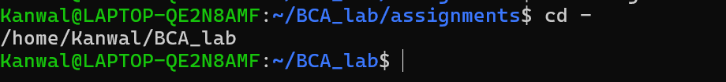

Experiment: 14
14.Find the first assignment file
Input: find . -name ‘assignment1.txt’

Output:
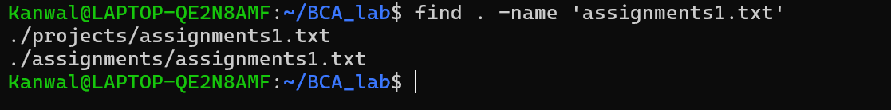

Experiment: 15
15.Enter projects
Input: cd projects

Output:

Experiment: 16
16.Remove the copy file from projects
Input: rm assignments1.txt

Output:



